Media Guide 2007

Higher School Certificate
and School Certificate

© 2007 Copyright Board of Studies NSW for and on behalf of the Crown in right of the State of New South Wales.

This document contains Material prepared by the Board of Studies NSW for and on behalf of the State of New South Wales.

The Material is protected by Crown copyright.

All rights reserved. No part of the Material may be reproduced in Australia or in any other country by any process, electronic or otherwise, in any material form or transmitted to any other person or stored electronically in any form without the prior written permission of the Board of Studies NSW, except as permitted by the Copyright Act 1968. School students in NSW and teachers in schools in NSW may copy reasonable portions of the Material for the purposes of bona fide research or study.

When you access the Material you agree:
- to use the Material for information purposes only
- to reproduce a single copy for personal bona fide study use only and not to reproduce any major extract or the entire Material without the prior permission of the Board of Studies NSW
- to acknowledge that the Material is provided by the Board of Studies NSW
- not to make any charge for providing the Material or any part of the Material to another person or in any way make commercial use of the Material without the prior written consent of the Board of Studies NSW and payment of the appropriate copyright fee
- to include this copyright notice in any copy made
- not to modify the Material or any part of the Material without the express prior written permission of the Board of Studies NSW.

The Material may contain third party copyright materials such as photos, diagrams, quotations, cartoons and artworks. These materials are protected by Australian and international copyright laws and may not be reproduced or transmitted in any format without the copyright owner’s specific permission. Unauthorised reproduction, transmission or commercial use of such copyright materials may result in prosecution.

The Board of Studies has made all reasonable attempts to locate owners of third party copyright material and invites anyone from whom permission has not been sought to contact the Copyright Officer, tel (02) 9367 8289,
fax (02) 9279 1482

Published by
Board of Studies NSW
GPO Box 5300
Sydney NSW 2001
Australia

Tel: (02) 9367 8111
Fax: (02) 9367 8484
Internet: www.boardofstudies.nsw.edu.au

October 2007

ISBN 1 7414 7430 2

2007585

Contents

- Important Dates 2
- 2007 HSC Facts at a Glance 2
- 2007 HSC and SC Enrolment Statistics by Region 6
- 2007 HSC Enrolment Statistics by Course 7
- The HSC Advice Line 10
- Release of HSC Results to Students 11
- HSC Examination Inquiry Centre 12
- Careers Advisory Services 12
- Maps of Board of Studies Regions 13
- Media Inquiries and Guidelines for Contacting Students 14

1 Important Dates
8 October HSC Advice Line opens on 13 11 12.
18 October Higher School Certificate written examinations begin.
12–16 November School Certificate tests.
8 November HSC Advice Line closes at 10 pm.
13 November Higher School Certificate written examinations finish.
3 December DesignTECH – a selection of the best HSC major works from 2007 Design and Technology students – launched at Powerhouse Museum, Sydney.
13 December School Certificate award documents arrive in schools.
18 December First-in-course awards ceremony and media conference re HSC Results Release at Sydney Conservatorium of Music.
19 December HSC results available to students by internet/SMS message/telephone.
Media conference releasing HSC results to media, venue TBC.
HSC Examination Inquiry Centre opens on 13 11 12.
20 December University Admissions Centre releases UAI rankings online for students (for information, see www.uac.edu.au).
Newspapers print embargoed HSC merit lists.
21 December HSC Student Results Summary delivered by mail.
Students receive written advice of UAI rankings.
15 January Formal HSC student credentials delivered by mail.
21 January Unveiling of Art Express works in David Jones windows.
4 February Official opening of Art Express at the Art Gallery of NSW.

2 2007 HSC Facts at a Glance
The Big Picture
- This year there are 67 189 HSC students.
- Most students will sit six exam papers each in about 750 exam centres including schools in Hong Kong, Indonesia, Malaysia and Singapore. There are 110 different examinations for courses ranging from English to Latin, Physics to Drama, and Software Design and Development to Primary Industries.
- Students will read from 13 million printed pages of questions and submit answers in 1.75 million writing booklets.
- A team of more than 30 people took nearly six weeks to pack all written examination papers for each exam centre, creating more than 50 000 parcels for distribution.
- The Board employs more than 5000 exam supervisors and more than 7000 markers.
- Marking takes place at venues across NSW, including Sydney, Bathurst, Coffs Harbour, Gosford, Newcastle, Tamworth, Wagga Wagga and Wollongong.
- Schools have submitted their locally assessed marks for each student; this means 50 per cent of students’ total HSC marks are already held on the Board’s secure system.
- Several million individual marks are processed to produce students’ examination marks in each course. The exam mark and the school mark are added together to produce the HSC mark.
- Each student’s performance is measured against consistent academic standards to create a fair and easily understood result for each student.

Top 15 subjects by enrolment 2007
Subject | Total
- English | 63 693
- Mathematics | 52 122
- Business Studies | 15 993
- Biology | 14 620
- Personal Development, Health and PE | 13 278
- Studies of Religion | 13 236
- Ancient History | 11 495
- Chemistry | 10 444
- Modern History | 9 769
- Visual Arts | 9 420
- Physics | 9 253
- Legal Studies | 8 799
- Hospitality | 7 747
- Economics | 5 762
- Music | 5 540

Enrolment trends
The candidature for the 2007 HSC is the highest on record with 67 189 students enrolled in one or more courses – passing the 67 000 mark for the first time.
The female to male ratio remains stable at 52 per cent female students compared with 48 per cent male students – the same as last year.
With around 1000 more students this year than in 2006, there have been slight increases in some courses. However, overall there have been no substantial changes in 12 months.
Given fluctuations in course enrolments from year to year, comparisons are provided with 2003 figures (comprising five HSCs) to illustrate any trends.
Some subject areas that may be of interest in 2007 are:
English
- English is the only mandatory subject in the HSC.
- The number of students taking the most demanding 2 unit course - English (Advanced) - continues to grow and now stands at 28 258 students, representing 44 per cent of all English enrolments and a 14 per cent increase on 2003.
Mathematics
- More than 52 000 Year 12 students have chosen to take Mathematics, which is by far the most popular HSC elective subject.
- This means 78 per cent of all HSC students are taking Mathematics.
- Of the total number of students eligible for an HSC in 2007, 55 394 students (or 88 per cent) are sitting a Mathematics exam or have completed a Year 11 or Year 12 course in Mathematics in previous years.
Science
- Almost half (44 per cent) of all HSC students are studying at least one science course.
- Enrolments in science courses have remained fairly stable. Biology has continued its growth to 14 620 candidates and remains the fourth largest HSC subject. Since 2003, the number of students taking Biology has increased by 18 per cent. Chemistry is the eighth largest subject with 10 444 students and Physics is the 11th largest with 9253.
History
- Almost a third (30 per cent) of HSC candidates are enrolled in a history course.
- Of all the HSC subjects, Ancient History has maintained the seventh largest enrolment with 11 495 students – an increase of 30 per cent on 2003 – and Modern History is in ninth position with 9769.
- There are 1960 students studying both Ancient and Modern History this year.
Economics
- The number of students taking Economics is growing. The 2007 total of 5762 is an increase of 10 per cent on 2003.
- Business Studies, a related course, continues to be popular. With 15 993 students it has the third highest candidature.
Technology courses
- There has been an increased uptake of technology courses among HSC students.
- Textiles and Design (2104) enrolments have risen by 34 per cent since 2003, while Food Technology (3372) increased by eight per cent in the same period.
- Engineering Studies experienced a 20 per cent rise in enrolments from 1290 in 2003 to 1554 in 2007.
Vocational Education and Training (VET)
- There are 20 579 students in Year 12 doing one or more VET courses. This represents almost 31 per cent of the candidature who will gain nationally recognised employment qualifications along with their HSC this year.
- A high percentage of VET students have opted to take examinations as part of their assessment, making their course eligible for a UAI ranking. For example, 87 per cent of Hospitality students and 85 per cent of Entertainment Industry students have chosen to sit the written HSC exam.
- Some of the fastest growing VET courses this year are Construction (up 32 per cent on 2003) and Metal and Engineering (up 13 per cent in that period). Hospitality remains the largest VET course with 7747 students, and has grown eight per cent since 2003.
- Accounting students have balanced the books with equal numbers of male and female students – 236.
Visual Arts
- Visual Arts is in 10th position with 9420 students.
- The best work of this year’s students will be included in the 25th anniversary of the Art Express exhibition which will be launched in Sydney this January before touring the rest of NSW during 2008.
Languages
- This year’s top three languages are again: French (1410 students), Japanese (1376 students) and Chinese (1147 students).
- Many language courses have shown significant increases since 2003. These include French Extension up 31 per cent to 221 and Japanese Beginners up 38 per cent to 634. Spanish Beginners, one of the smaller courses, has more than doubled from 74 to 168, an increase of 127 per cent.
- The 10 most popular language subjects include five European languages (French, Italian, German, Spanish and Modern Greek) and three Asian languages (Japanese, Chinese and Indonesian), while one is Middle-Eastern (Arabic) and one is classical (Latin).
Top 10 languages by enrolment:
Subject | Total
- French | 1410
- Japanese | 1376
- Chinese | 1147
- Italian | 719
- German | 568
- Spanish | 376
- Arabic | 237
- Indonesian | 215
- Latin | 184
- Modern Greek | 169

3 2007 HSC and SC Enrolment Statistics by Region
The locations are based on the Board of Studies regions. See the maps in Section 9 of this guide. Students doing the HSC outside of NSW and those studying by self-tuition are included in ‘Other Categories’.
2007 HSC candidates by geographical location
Location | Female | Male | Total | Percentage
Metropolitan
Metropolitan East | 5453 | 5286 | 10739 | 15.98%
Metropolitan North | 5174 | 5329 | 10503 | 15.63%
Metropolitan North West | 4386 | 3927 | 8313 | 12.37%
Metropolitan South West | 5183 | 4727 | 9910 | 14.75%
Total | 20196 | 19269 | 39465 | 58.74%
Country
Hunter | 3839 | 3337 | 7176 | 10.68%
North Coast | 2750 | 2416 | 5166 | 7.69%
North West | 1182 | 925 | 2107 | 3.14%
Riverina | 1672 | 1367 | 3039 | 4.52%
South Coast | 3521 | 3139 | 6660 | 9.91%
Western | 1671 | 1404 | 3075 | 4.58%
Total | 14635 | 12588 | 27223 | 40.52%
Other Categories | 173 | 328 | 501 | 0.75%
Total of all Categories | 35004 | 32185 | 67189 | 100%
Candidates by institution type
School students | 65698 | 97.78%
TAFE students | 1479 | 2.20%
Self-tuition students | 12 | 0.02%
Total | 67189 | 100.00%

2007 School Certificate candidates by geographical location
Location | Female | Male | Total | Percentage
Metropolitan
Metropolitan East | 5217 | 5453 | 10670 | 12.30%
Metropolitan North | 5637 | 5670 | 11307 | 13.04%
Metropolitan North West | 5489 | 5660 | 11149 | 12.85%
Metropolitan South West | 6246 | 6595 | 12841 | 14.80%
Total | 22589 | 23378 | 45967 | 52.99%
Country
Hunter | 5257 | 5636 | 10893 | 12.56%
North Coast | 3741 | 3996 | 7737 | 8.92%
North West | 1577 | 1594 | 3171 | 3.66%
Riverina | 2241 | 2384 | 4625 | 5.33%
South Coast | 4604 | 4860 | 9464 | 10.91%
Western | 2341 | 2341 | 4682 | 5.40%
Total | 19761 | 20811 | 40572 | 46.77%
Other Categories | 93 | 108 | 201 | 0.23%
Total of all Categories | 42443 | 44297 | 86740 | 100%
4 2007 HSC Enrolment Statistics by Course
2007 HSC Student enrolments by subject, course and gender
Course Name | Units | Female | Male | Total
HSC Courses
Aboriginal Studies | 2 | 233 | 90 | 323
Agriculture | 2 | 559 | 715 | 1274
Ancient History | 2 | 6839 | 4656 | 11495
Biology | 2 | 9147 | 5473 | 14620
Business Studies | 2 | 7887 | 8106 | 15993
Chemistry | 2 | 4702 | 5742 | 10444
Community & Family Studies | 2 | 4530 | 268 | 4798
Dance | 2 | 687 | 29 | 716
Design and Technology | 2 | 1647 | 2298 | 3945
Distinction Course – Comparative Literature | 2 | 11 | 3 | 14
Distinction Course – Cosmology | 2 | 8 | 22 | 30
Distinction Course – Philosophy | 2 | 30 | 24 | 54
Drama | 2 | 3589 | 1527 | 5116
Earth & Environmental Science | 2 | 565 | 692 | 1257
Economics | 2 | 2247 | 3515 | 5762
Engineering Studies | 2 | 61 | 1493 | 1554
English (Advanced) | 2 | 16647 | 11611 | 28258
English (Standard) | 2 | 14798 | 16565 | 31363
English as a Second Language | 2 | 1334 | 1393 | 2727
English Extension 1 | 1 | 4070 | 2178 | 6248
English Extension 2 | 1 | 1708 | 846 | 2554
Food Technology | 2 | 2541 | 831 | 3372
Geography | 2 | 2179 | 2382 | 4561
History Extension | 1 | 1359 | 919 | 2278
Industrial Technology | 2 | 264 | 3352 | 3616
Information Processes and Technology | 2 | 1517 | 3744 | 5261
Legal Studies | 2 | 5420 | 3379 | 8799
General Mathematics | 2 | 15258 | 14488 | 29746
Mathematics | 2 | 8326 | 9808 | 18134
Mathematics Extension 1 | 1 | 3727 | 5132 | 8859
Mathematics Extension 2 | 2 | 1173 | 1903 | 3076
Modern History | 2 | 5302 | 4467 | 9769
Music 1 | 2 | 2141 | 2700 | 4841
Music 2 | 2 | 371 | 321 | 692
Music Extension | 1 | 210 | 195 | 405
Personal Development, Health & Physical Education | 2 | 6805 | 5722 | 12527
Physics | 2 | 2264 | 6989 | 9253
Senior Science | 2 | 1872 | 2405 | 4277
Society and Culture | 2 | 3110 | 621 | 3731
Software Design & Development | 2 | 147 | 1730 | 1877
Studies of Religion I | 1 | 5429 | 4743 | 10172
Studies of Religion II | 2 | 2102 | 962 | 3064
Textiles and Design | 2 | 2062 | 42 | 2104
Visual Arts | 2 | 6513 | 2907 | 9420

Course Name | Units | Female | Male | Total
Languages
Arabic Continuers | 2 | 138 | 98 | 236
Arabic Extension | 1 | 43 | 33 | 76
Armenian Continuers | 2 | 15 | 8 | 23
Chinese Background Speakers | 2 | 487 | 512 | 999
Chinese Beginners | 2 | 17 | 1 | 18
Chinese Continuers | 2 | 69 | 61 | 130
Chinese Extension | 1 | 20 | 19 | 39
Classical Greek Continuers | 2 | 6 | 10 | 16
Classical Greek Extension | 1 | 4 | 8 | 12
Classical Hebrew Continuers | 2 | 38 | 16 | 54
Classical Hebrew Extension | 1 | 20 | 12 | 32
Croatian Continuers | 2 | 11 | 13 | 24
Dutch Continuers | 2 | 2 | 2 | 4
Filipino Continuers | 2 | 10 | 11 | 21
French Beginners | 2 | 470 | 80 | 550
French Continuers | 2 | 603 | 241 | 844
French Extension | 1 | 141 | 80 | 221
German Beginners | 2 | 88 | 50 | 138
German Continuers | 2 | 244 | 180 | 424
German Extension | 1 | 66 | 59 | 125
Hindi Continuers | 2 | 23 | 17 | 40
Hungarian Continuers | 2 | 2 | 5 | 7
Indonesian Background Speakers | 2 | 44 | 42 | 86
Indonesian Beginners | 2 | 35 | 8 | 43
Indonesian Continuers | 2 | 59 | 27 | 86
Indonesian Extension | 1 | 15 | 9 | 24
Italian Beginners | 2 | 282 | 59 | 341
Italian Continuers | 2 | 274 | 94 | 368
Italian Extension | 1 | 37 | 15 | 52
Japanese Background Speakers | 2 | 26 | 29 | 55
Japanese Beginners | 2 | 408 | 226 | 634
Japanese Continuers | 2 | 427 | 250 | 677
Japanese Extension | 1 | 140 | 98 | 238
Khmer Continuers | 2 | 9 | 6 | 15
Korean Background Speakers | 2 | 58 | 61 | 119
Korean Continuers | 2 | 4 | 1 | 5
Latin Continuers | 2 | 75 | 105 | 180
Latin Extension | 1 | 34 | 66 | 100
Macedonian Continuers | 2 | 12 | 10 | 22
Maltese Continuers | 2 | 2 | 1 | 3
Modern Greek Beginners | 2 | 30 | 12 | 42
Modern Greek Continuers | 2 | 71 | 56 | 127
Modern Greek Extension | 1 | 33 | 19 | 52
Modern Hebrew Continuers | 2 | 27 | 18 | 45
Persian Background Speakers | 2 | 21 | 22 | 43
Polish Continuers | 2 | 18 | 17 | 35
Portuguese Continuers | 2 | 11 | 7 | 18
Russian Background Speakers | 2 | 11 | 12 | 23
Serbian Continuers | 2 | 18 | 6 | 24
Spanish Beginners | 2 | 132 | 36 | 168
Spanish Continuers | 2 | 131 | 77 | 208
Spanish Extension | 1 | 59 | 20 | 79
Swedish Continuers | 2 | 7 | 4 | 11
Course Name | Units | Female | Male | Total
Tamil Continuers | 2 | 9 | 11 | 20
Turkish Continuers | 2 | 42 | 19 | 61
Ukrainian Continuers | 2 | 1 | 0 | 1
Vietnamese Continuers | 2 | 75 | 53 | 128
Vocational Education and Training
Accounting | 2 | 236 | 236 | 472
Business Services |  | 1852 | 485 | 2337
Business Services Extension |  | 6 | 0 | 6
Business Services Examination | 2 | 1406 | 310 | 1716
Construction |  | 28 | 2235 | 2263
Construction Specialisation Studies |  | 0 | 17 | 17
Construction Examination | 2 | 22 | 1767 | 1789
Entertainment Industry |  | 442 | 489 | 931
Entertainment Industry Examination | 2 | 390 | 400 | 790
Hospitality |  | 5346 | 2401 | 7747
Hospitality Extension |  | 129 | 72 | 201
Hospitality Examination | 2 | 4706 | 2010 | 6716
Information Technology |  | 728 | 2104 | 2832
Information Technology Specialisation Studies |  | 3 | 48 | 51
Information Technology Examination | 2 | 547 | 1788 | 2335
Metal and Engineering |  | 19 | 822 | 841
Metal and Engineering Extension – Specialist Studies |  | 1 | 39 | 40
Metal and Engineering Examination | 2 | 16 | 609 | 625
Primary Industries |  | 237 | 439 | 676
Primary Industries Extension/Specialisation Studies |  | 7 | 22 | 29
Primary Industries Examination | 2 | 197 | 331 | 528
Retail Operations |  | 1534 | 656 | 2190
Retail Operations Examination | 2 | 1225 | 492 | 1717
Tourism | 2 | 438 | 45 | 483
Tourism Extension |  | 5 | 0 | 5
Tourism Examination | 2 | 336 | 31 | 367
Life Skills
Citizenship and Society Life Skills | 2 | 235 | 337 | 572
Creative Arts Life Skills | 2 | 271 | 342 | 613
English Life Skills | 2 | 541 | 768 | 1309
Mathematics Life Skills | 2 | 452 | 649 | 1101
Personal Development, Health & PE Life Skills | 2 | 293 | 458 | 751
Science Life Skills | 2 | 149 | 242 | 391
Technology & Applied Studies Life Skills | 2 | 289 | 458 | 747
Work and the Community Life Skills | 2 | 347 | 494 | 841

Note: There are multiple courses available within each VET industry framework, allowing for flexible delivery throughout Stage 6. The courses have been combined to show entries in the base course, entries in any extension or specialisation courses and the entries in the optional examination. Due to the consolidation, no course number or unit value can be shown for these courses.

5 The HSC Advice Line – 13 11 12
The Advice Line is a telephone information service for students preparing for the HSC examinations. It provides an after-hours and weekend service leading up to and during the examination period. The Advice Line has received almost 320 000 calls since it began in 1995.

The 2007 HSC Advice Line opened on Monday 8 October. It will close at 10 pm on Thursday 8 November 2007.

The service is open from:
Monday to Friday 4 pm to 10 pm
Saturday 10 am to 6 pm
Sunday 10 am to 10 pm

The HSC Advice Line telephone number is 13 11 12.
The cost is only 25 cents, no matter where a student is calling from in NSW or how long the call lasts. Calls to the Advice Line cannot be made from mobile phones.

Up to 80 lines are open at any one time for teachers to answer questions, no matter how simple or complex. Some of the questions students commonly ask are:
What kinds of exam questions will be asked in this subject?
How do I structure an essay or use quotes and reference material?
Do I have the right answer to the question in the specimen exam paper?
I need more information on this topic – help!
What equipment do I need to take into the exam room?

6 Release of HSC Results to Students
The HSC results are available to students via the internet, SMS text message and automated telephone services from 6 am on Wednesday 19 December. Students will receive HSC results summaries in the mail on Friday 21 December and their full credentials on Tuesday 15 January 2008.
The pre-Christmas release of HSC results gives students more time to take advantage of career counselling and other support services before making decisions about university, TAFE and employment offers or other plans
The Internet Results Service
- Students can access their HSC results on three Board of Studies websites from
6 am on Wednesday 19 December by typing in their student number and PIN at:
www.boardofstudies.nsw.edu.au
or
www.hscresults.nsw.edu.au
or
www.hsc-results.nsw.edu.au
- There is no cost to students who use a website other than the charges applied by their internet service provider and/or the cost of the call.
Release of results by SMS text message – 0427 659 900
- Students who want to automatically receive their HSC results by SMS can pre-register for the SMS service by text-messaging their student number and PIN to 0427 659 900. Registrations for results delivery via SMS commence on Monday, November 5, 2007
- A return text message to the student confirms that they have registered for the service and the results will be sent to their mobile phone at approximately 6 am on 19 December.
- Students who do not pre-register can still get their results by SMS by messaging their student number and PIN to the service after 6 am on 19 December.
- Students should check that their phone is in credit and that there is room for messages in their phone’s inbox.
- The SMS service will be charged at the standard price of a text message.
The Telephone Results Service – 1300 669 248
- Students can access their HSC results from 6 am on Wednesday 19 December by using the automated telephone service.
- Students call 1300 669 248 and follow the voice prompts. They will be asked to enter their student number and PIN.
- Calls will be charged at standard local call rates. Mobile and payphone calls are extra.

7 HSC Examination Inquiry Centre – 13 11 12
The HSC Examination Inquiry Centre will operate from 9 am on Wednesday 19 December 2007 until the New Year. Students can talk to experienced Board of Studies and school staff about their Higher School Certificate results.

Inquiries relating to the UAI, university admissions, post-secondary education and work should be directed to the Universities Admissions Centre or the annual Careers Advisory Service for School Leavers.
8 Careers Advisory Services – www.cas.det.nsw.edu.au
Each year, following the release of the Higher School Certificate results, the NSW Department of Education and Training offers free Careers Advisory Services which provide students and their families or caregivers with up-to-date and relevant information about the range of available career and study options.
The Careers Advisory Services will be open from Wednesday 19 December 2007 to Friday 18 January 2008. Students can contact the service by calling 1300 300 687, or email careers@det.nsw.edu.au.
More information and contact details are available at www.cas.det.nsw.edu.au.

9 Maps of Board of Studies Regions

New South Wales
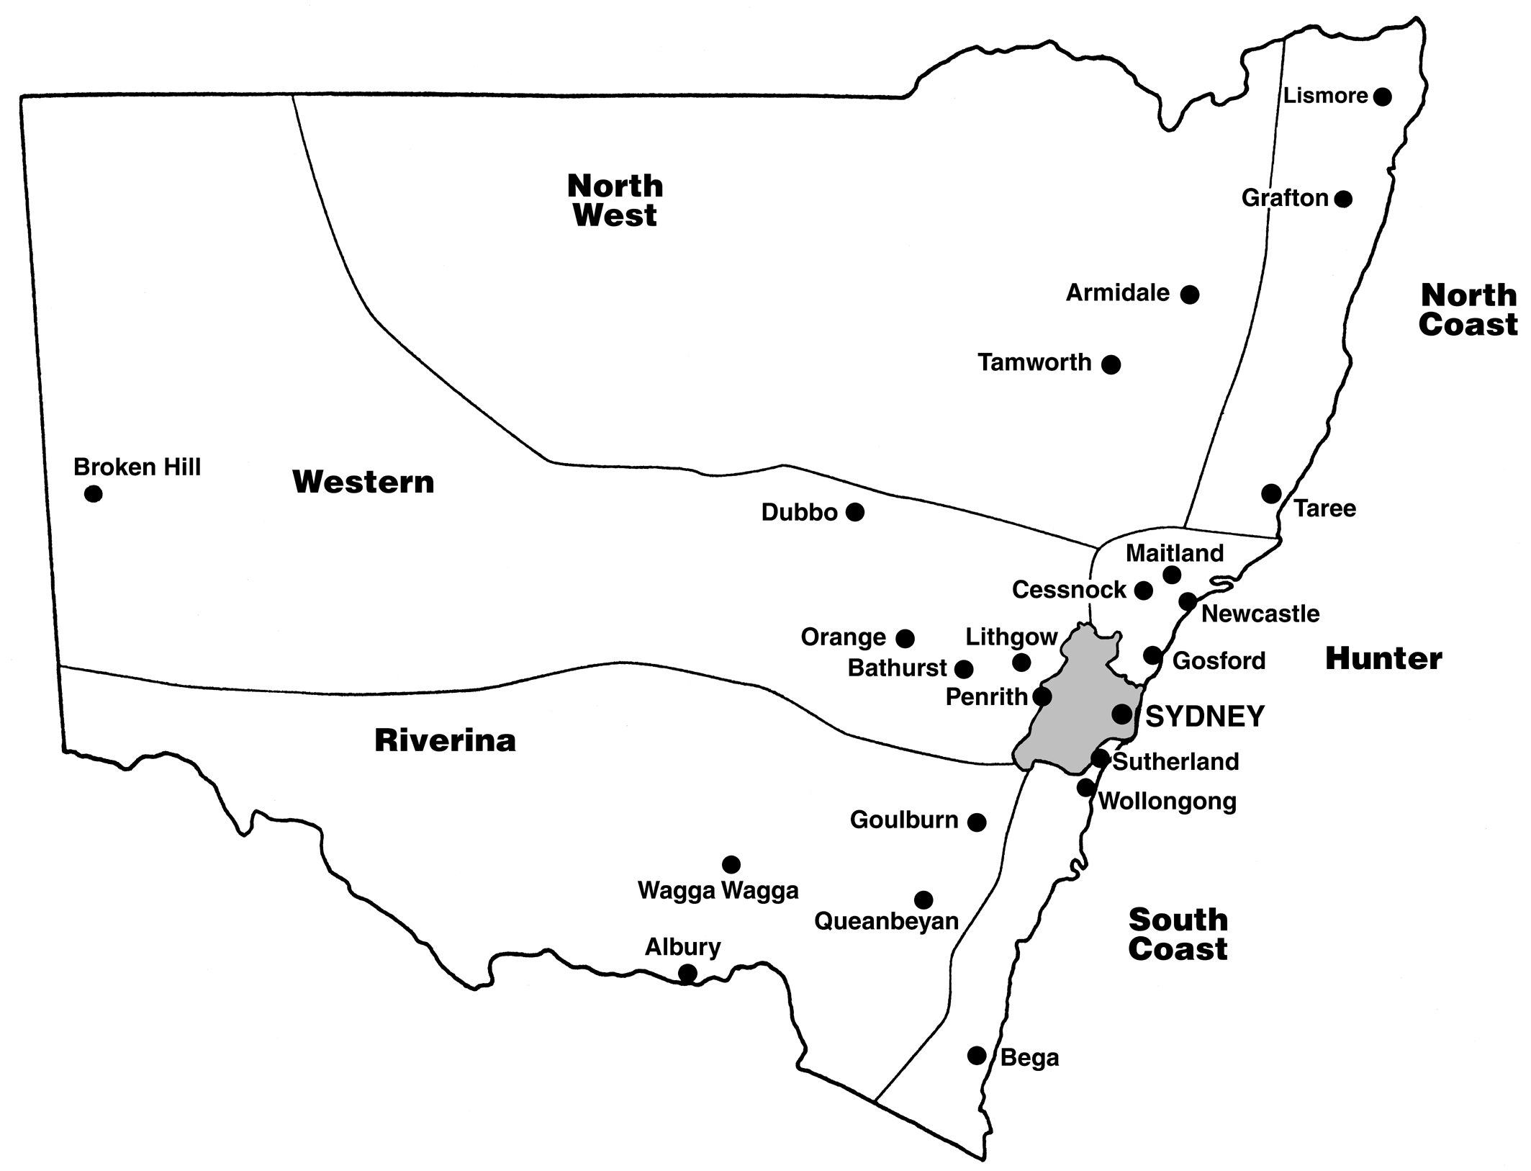
Sydney Metropolitan

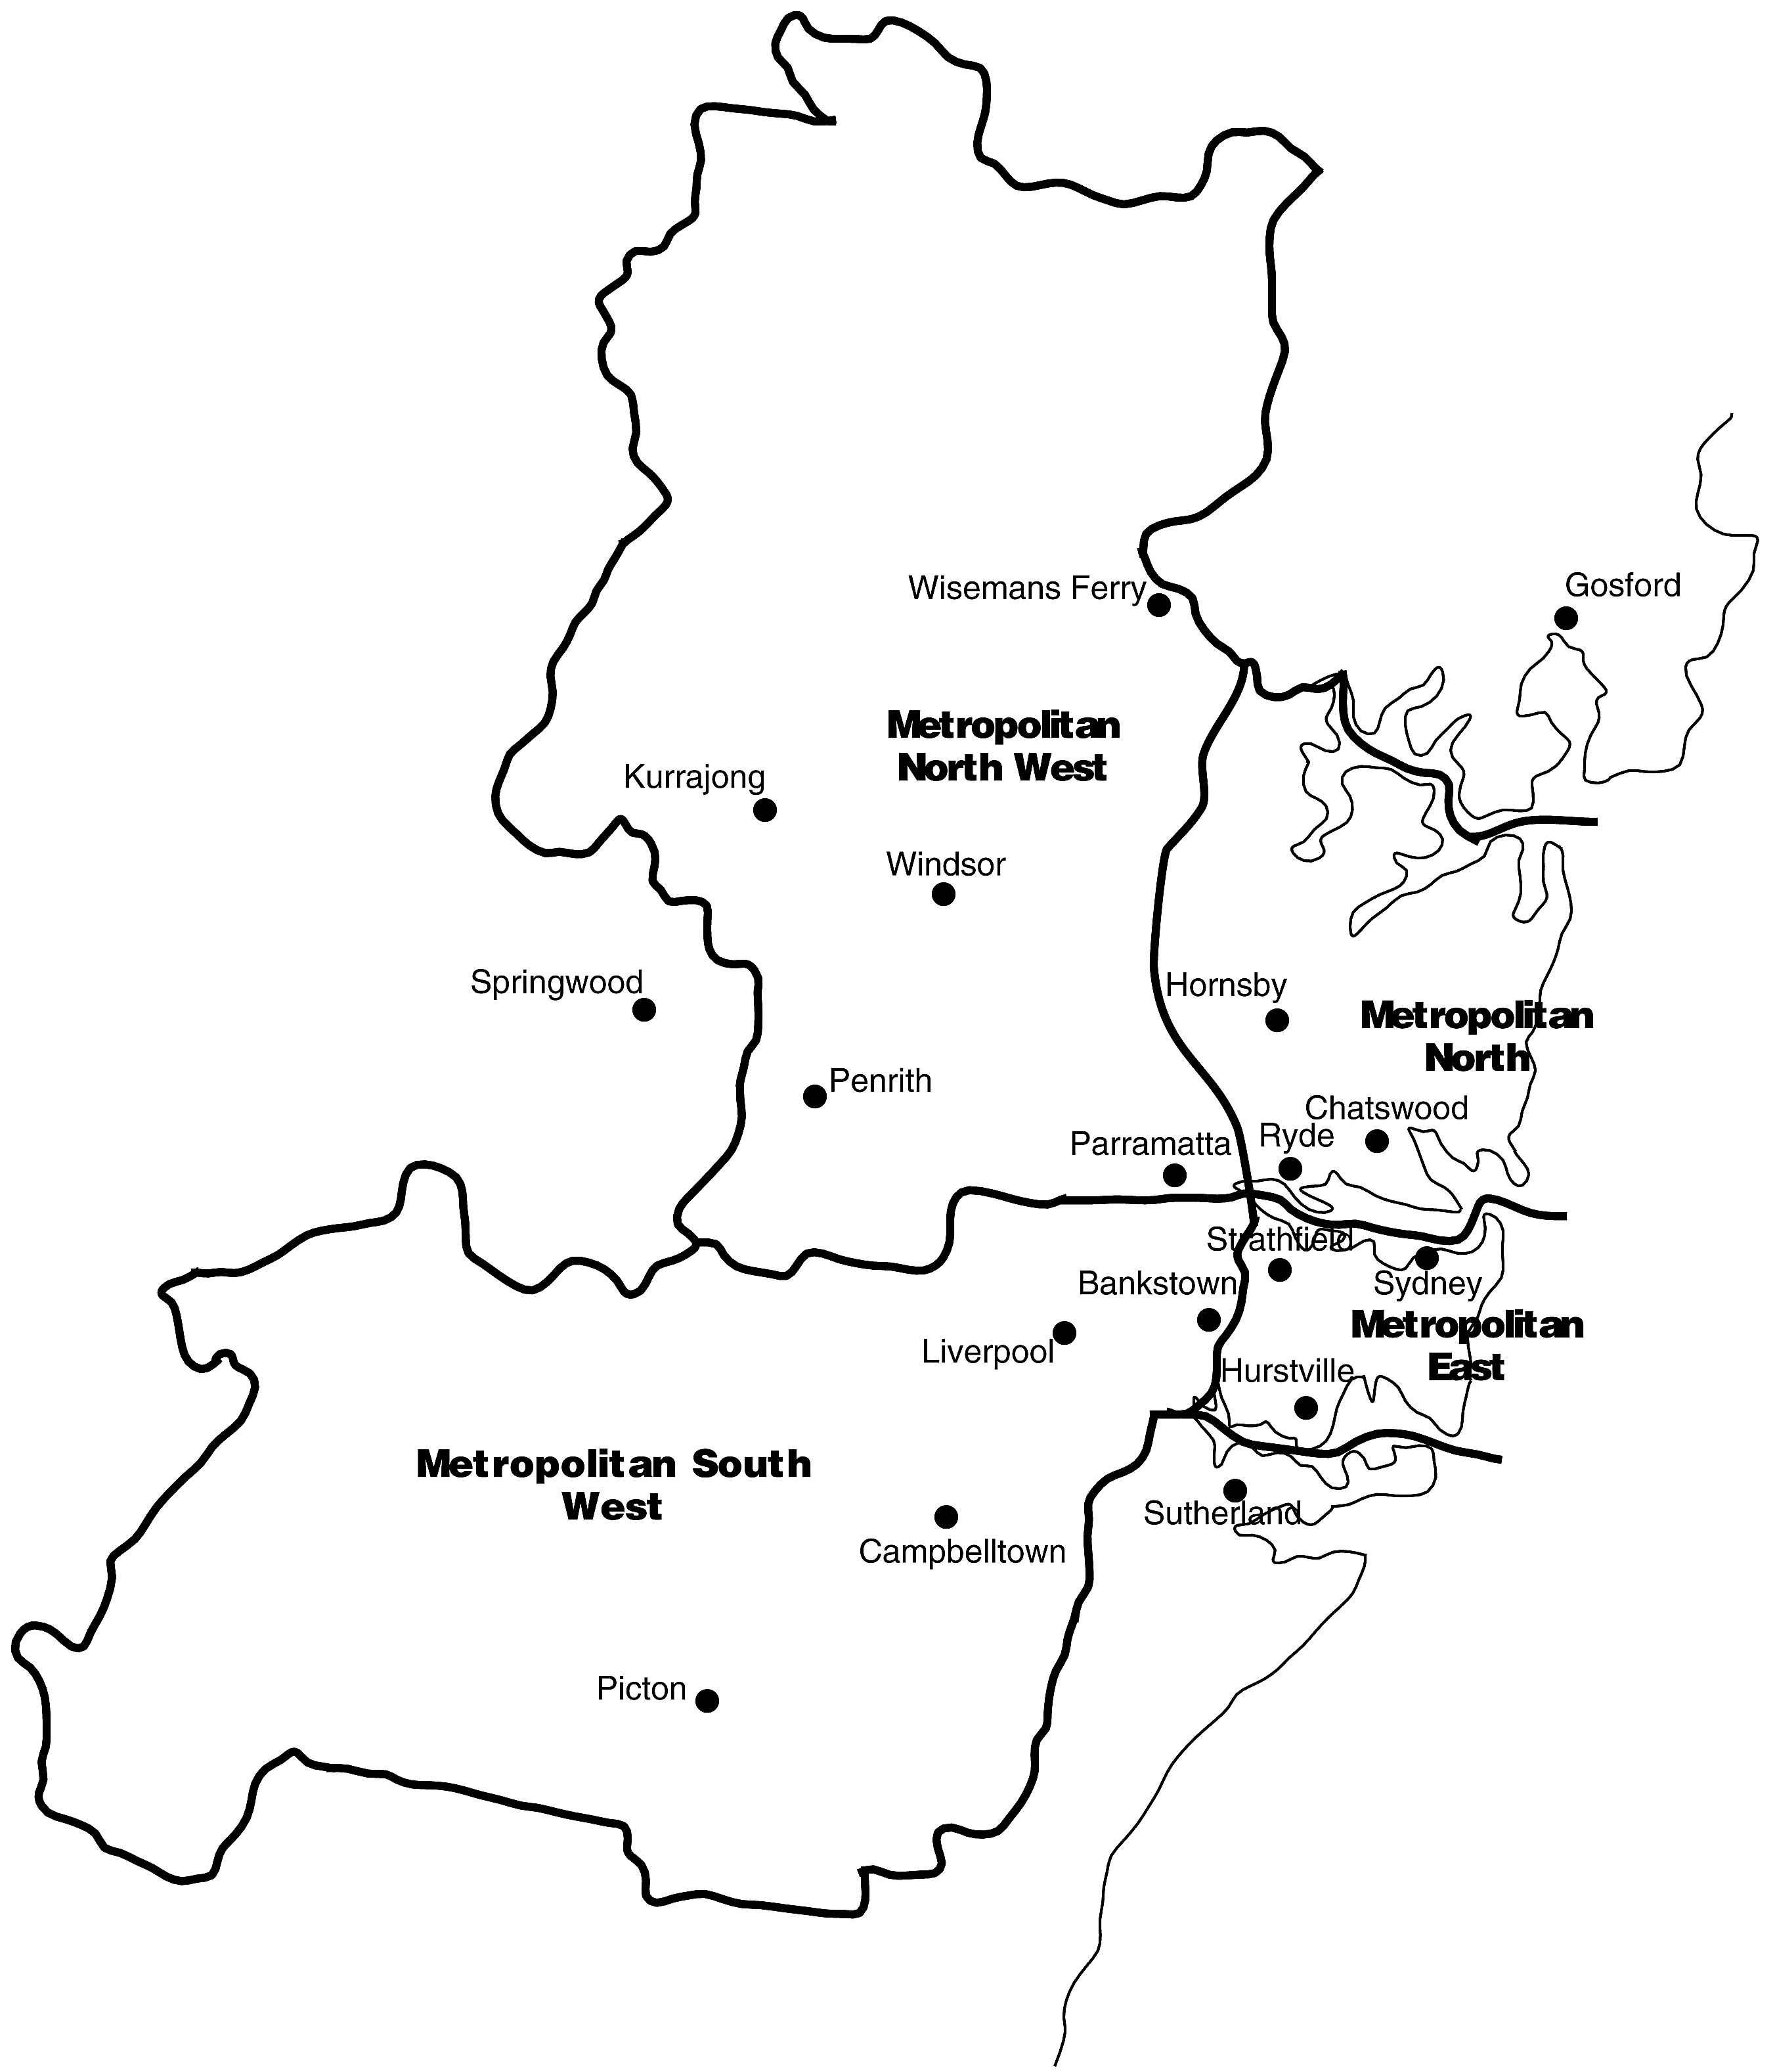
10 Media Inquiries and Guidelines for Contacting Students
Media Inquiries
Please direct all your HSC media inquiries to:
Natalie Laharnar
Chief Media Officer
Office of the Board of Studies
Tel: (02) 9367 8066
Mobile: 0438 497 766
Fax: (02) 9367 8035
Email: natalie.laharnar@bos.nsw.edu.au

Guidelines for Contacting Students and Schools
It's important that students are free to concentrate solely on their exams. For this reason media outlets should not attend schools before or during exams.
- Mock-up shots after the exam can be arranged to provide images of students concentrating on their exam papers. Call the Board of Studies to make arrangements.
- Journalists seeking access to a government school or telephone interviews with teachers should contact a Department of Education and Training media liaison officer on (02) 9561 8501, preferably 24 hours in advance.
- Journalists seeking access to a non-government school should contact the school principal directly.
- Be aware that in some cases parental permission must be obtained for students to be photographed or filmed or otherwise identified or interviewed. Check this with the principal.
- Always notify the school principal on your arrival at the school.

Please call the above media inquiries number at any time with questions or special requests.

Additional media information and copies of this Media Guide can be found on the Board of Studies website:

www.boardofstudies.nsw.edu.au

